Name:___________________
Biology Midterm Study Guide

- Photosynthesis uses sunlight to convert water and carbon dioxide into
  - oxygen
  - ATP and oxygen
  - high energy sugars and starches
  - oxygen and high energy sugars

- Breathing heavily after running a race is your body's way of
  - repaying an oxygen debt
  - recharging the ETC
  - making more citric acid
  - restarting glycolysis
- Unlike photosynthesis, cellular respiration occurs in
  - plant cells only
  - plant and animal cells
  - animal cells only
  - all but plant cells
- If carbon dioxide is completely removed from a plant's environment, what would you expect to happen to the plant's production of high energy sugars?
  - no sugars will be produced
  - the same amount of sugar will be produced
  - carbon dioxide does not affect the production of sugar
  - more sugars will be produced
- Energy is released from ATP when
  - adenine bonds to ribose
  - a phosphate group is added
  - a phosphate group is removed
  - ATP is exposed to light
- Which organelle provides the cell with energy?
  - ER
  - ribosomes
  - mitochondria
  - golgi
- The products of photosynthesis are
  - products of glycolysis
  - products of cellular respiration
  - reactants of cellular respiration
  - reactants of fermentation
- Cellular respiration releases energy by breaking down
  - ATP
  - carbon dioxide
  - water
  - food molecules
- One cause of muscle soreness after exercise is
  - lactic acid fermentation
  - glycolysis
  - alcoholic fermentation
  - kreb cycle
- A tissue is composed of specialized
  - organisms
  - organs
  - systems
  - cells
- Which organisms contain chlorophyll in their cells?
  - earthworms
  - grasshoppers
  - algae
  - tapeworms
- What is the smallest unit of life in all living things called?
  - an atom
  - a molecule
  - a cell
  - bacteria
- Put the level of organization in order from smallest to largest.
  - organs, tissues, cells, and organ system
  - cells, organs, tissues, and organ systems
  - organ system, organs, tissues, and cells
  - cells, tissues, organs, and organ systems
- Where is the hereditary material located in the cell?
  - the mitochondrion
  - the nucleus
  - the cell membrane
  - the vacuole
- Which of the following does NOT have organelles?
  - fungi
  - bacteria
  - plants
  - algae
- What part of the cell helps control what enters and leaves the cell?
  - cell membrane
  - cytoplasm
  - mitochondrion
  - nucleus
- Which two structures do plant cells have that animal cells do not have?
  - chromosomes and chlorophyll
  - cell membrane and a nucleus
  - chloroplasts and a cell wall
  - vacuoles and chloroplasts
- What type of instrument is used to look at cells?
  - microscope
  - telescope
  - glasses
  - binoculars
- What is the function of a nerve cell?
  - to receive and deliver messages
  - to form a protective layer for your body
  - to contract and relax muscles
  - to store fat
- Cells that contain membrane bound organelles are called
  - eukaryotic cells
  - prokaryotic cells
  - viruses
  - subkaryotic cells
- There are more of these in a muscle cell than there are in a skin cell
  - cell membrane
  - endoplasmic reticulum
  - lysosomes
  - mitochondria
- The Cell Theory states that all cells come from
  - non-living material
  - nothingness
  - other existing cells
  - none of these
- The cell membrane is composed of
  - a single layer of proteins
  - a phospholipid bi-layer
  - a carbohydrate bi-layer
  - a single layer of lipids
- Lactic acid fermentation occurs in
  - bread dough
  - muscle cells
  - any environment
  - mitochondria

- Which process is used to make beer and wine?
  - alcoholic fermentation
  - glycolysis
  - kreb cycle
  - lactic acid fermentation

- Respiration without the presence of oxygen is:
  - Random
  - Aerobic
  - Non Existent
  - Anaerobic

- The molecule that is capable of delivering the required energy to the cell is:
  - ATP
  - Carbon Dioxide
  - ADP
  - Pyruvic Acid

- The pigment in green plants that captures the energy in sunlight is called _________
  - chlorophyll
  - chromatid
  - nucleus
  - mitochondria

- During photosynthesis, plants produce sugars and __________.
  - oxygen
  - lactic acid
  - alcohol
  - carbon dioxide

- One of the products of respiration is carbon dioxide.
  - True
  - False

- Carbon dioxide enters a plant through its
  - nucleus
  - mitochondria
  - stomata
  - chloroplasts

- Based on the data in the table, in which container was photosynthesis not occurring?
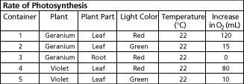
- container 4
- container 1
- container 5
- container 3

- The equation, 6CO2 + 6H2O → C6H12O6 + 6O2, describes which of the following processes?
- photosynthesis
- light reaction
- nitrogen fixation
- aerobic respiration

In the space at the left of each Function in Column A, place the letter of the Organelle in Column B that is most closely related to that function.

Column A Column B

_____ 1. Provides a boundary between the cell and its environment. A. Chloroplasts
_____ 2. Watery cell fluid that contains the cell organelles. B. Cell Wall
_____ 3. Controls cell activities. C. Vacuole
_____ 4. Involved in the production of ribosomes. D. Cytoplasm
_____ 5. Destroys damaged or old cell parts. E. Mitochondria
_____ 6. Involved in cell respiration. F. Centrioles
_____ 7. Synthesizes, packages, and secretes cell products. G. Nucleus
_____ 8. System of channels that transport materials throughout the cell. H. Plasma Membrane
_____ 9. Stores water and food. I. Golgi Complex
_____ 10. Involved in cell division. J. Lysosomes
_____ 11. Involved in photosynthesis. K. Nucleolus
_____ 12. Surrounds the cell membrane and gives the plant its shape. L. Endoplasmic Reticulum

Label this animal cell diagram:

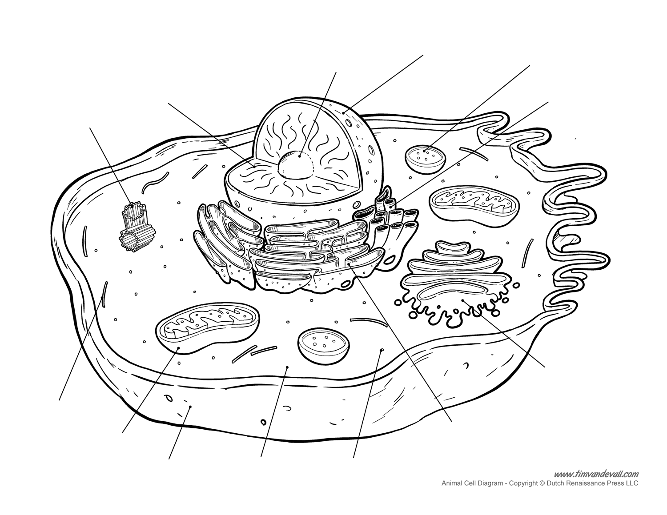

- What branch of science studies the origin, structure, and function of living things?
  - anthropology
  - ecology
  - taxonomy
  - biology
- The specific location where a substrate binds on an enzyme is called the ____.
  - active site
  - enzyme-substrate complex
  - binding point
  - catalyst
- The tested factor that can affect the outcome of a controlled experiment is called the ____.
  - dependent variable
  - data source
  - control group
  - independent variable
- Matter is composed of tiny particles called ____.
  - oxygen
  - atoms
  - electrons
  - neutrons
- Which of the pHs listed below represents the strongest base?
  - 7
  - 10
  - 13
  - 15

- Negatively charged particles that move around the nucleus of an atom are called ____.
  - isotopes
  - neutrons
  - protons
  - electrons
- How are the water molecules in a raindrop held together?
  - covalent bonds
  - hydrogen bonds
  - attraction between positive charges
  - attraction between negative charges
- Which of the following pH values represents the strongest acid?
  - 4
  - 10
  - 2
  - 12
- Molecules that have an unequal distribution of charges are called ____.
  - enzymes
  - polar molecules
  - substrate molecules
  - solvents
- Fatty molecules containing mostly carbon and hydrogen are called ____.
  - enzymes
  - proteins
  - lipids
  - catalysts
- Small compounds that form proteins are called ____.
  - amino acids
  - lipids
  - carbohydrates
  - phospholipids

- How many different kinds of atoms does an element contain?
  - six
  - two
  - four
  - one
- What is the function of the enzyme-substrate complex?
  - destroy the enzyme
  - prevent bondage at the active site
  - stop chemical reactions
  - break and form chemical bonds
- Which combination of particle and charge is correct?
- proton: positively charged
- electron: positively charged
- neutron: negatively charged
- proton: negatively charged
- electron: no charge
- Which of the following statements about water is false?
  - water molecules are polar
  - it takes very little heat to change the temperature of water
  - all living organisms contain water
  - ice is less dense than liquid water
  - none; all these statements are true
- Hydrogen bonds form when hydrogen in one polar molecule is attracted to the electronegative portion of another molecule.
  - True
  - False
- The properties of water are due to the polarity of the water molecule.
  - True
  - False
- Nucleotides consist of a phosphate group, a nitrogenous base, and a
- fatty acid.
- starch.
- lipid.
- sugar.
- An attraction between different substances
- Cohesion
- Adhesion
- Catalysts
- Reactants
- Products
- The atomic mass of an element is determined by its total number of
  - orbitals
  - electrons and protons
  - electrons and neutrons
  - protons and neutrons

- Which of the following are functions of nucleic acids?
  - They help make proteins.
  - They contain instructions for proteins.
  - They pass instructions from parents to offspring.
  - all of the above

Questions 26–27 Study the graph to answer the questions that follow.
The enzyme catalase speeds up the chemical reaction that changes hydrogen peroxide into oxygen and water. The amount of oxygen given off is an indication of the rate of the reaction.
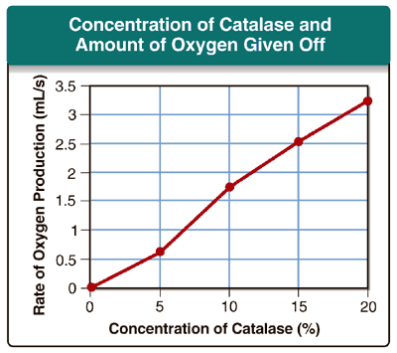

26. Based on the graph, what can you conclude about the relationship between enzyme concentration and reaction rate?
A. Reaction rate decreases with increasing enzyme concentration.
B. Reaction rate increases with decreasing enzyme concentration.
C. Reaction rate increases with increasing enzyme concentration.
D. The variables are indirectly proportional.
E. The variables are not related.

27. Which concentration of catalase will produce the fastest reaction rate?
A. 0%
B. 5%
C. 10%
D. 15%
E. 20%

